Unpacking Shipping Containers
November 4, 2015 By SCLAA With Comments are off for this post
In the last five years SafeWork NSW has investigated 21 incidents in NSW involving workers unpacking shipping containers. Three of these workers were killed.
The most serious incidents involved unpacking sheet material such as glass, stone, sandwich panels and timber.
SafeWork NSW is running a program to highlight the risks associated with unpacking shipping containers and to provide simple advice on how to manage these risks. A video safety alert and guidance material will be available in the coming months.
If freight isn’t packed with safe unloading in mind, or if it becomes unstable during transit, workers unpacking it can be at risk of serious injury or death.
If you unpack shipping containers, use these simple tips to keep your people safe.
WORKING WITH SUPPLIERS
Work with suppliers to ensure the load is appropriately packed for safe transit and unpacking. Ask them to use racks or crates, and to secure freight with wrapping or strapping. You can also ask suppliers to use containers that are open at both ends or have an open top for safer access.
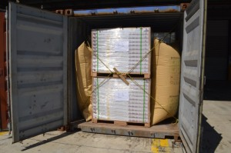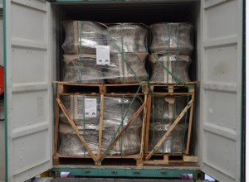
Bulky items packed using crates, wrapping, dunnage bags and strapping
PLAN THE WORK
Plan before you unpack the container and consider what equipment you will need. Choose an area with flat ground and unpack at ground level where possible. Be careful when opening the container in case the load has shifted. Keep looking for risks as you unpack, and adjust your plan as conditions change. Instruct workers about safety procedures and make sure they are appropriately experienced and supervised.
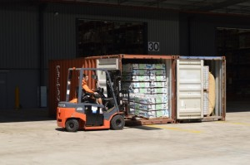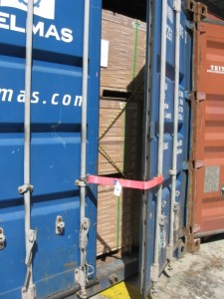 Use restraints to ensure safe opening of doors

Ensure the container is placed on even ground

USE THE RIGHT EQUIPMENT
Use a crane or forklift with attachments such as grabs, spikes or slippers, to avoid manual unloading. Never allow people in or around the container while using machinery to unload. If you’re using a crane and it’s necessary to guide the load, make sure it’s from a safe distance using a tag-line.
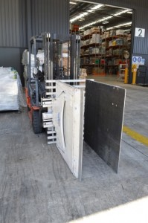

Using suitable equipment to unload such as grabs or jibs

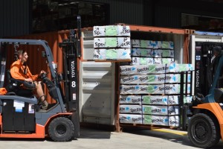

Dual lift to unpack long items

RESTRAIN OBJECTS WHEN WORKERS ARE IN THE CONTAINER
Never allow workers inside the container if there is any risk of objects moving and trapping them. Where there is a risk, brace freight with suitably rated restraint devices such as props, braces or frames. Secure freight for as long as possible by only removing restraints as necessary during unpacking.
GET HELP WHEN YOU NEED IT
And remember, you should always ask for help if you don’t have the equipment or expertise to safely unpack a container. Hiring equipment or engaging specialists to do the work can help.
If you have any questions on how to unpacking shipping containers safely, please phone SafeWork NSW on 13 10 50.

