SAFE WORK AUSTRALIA

Mindfulness of work health and safety in the workplace

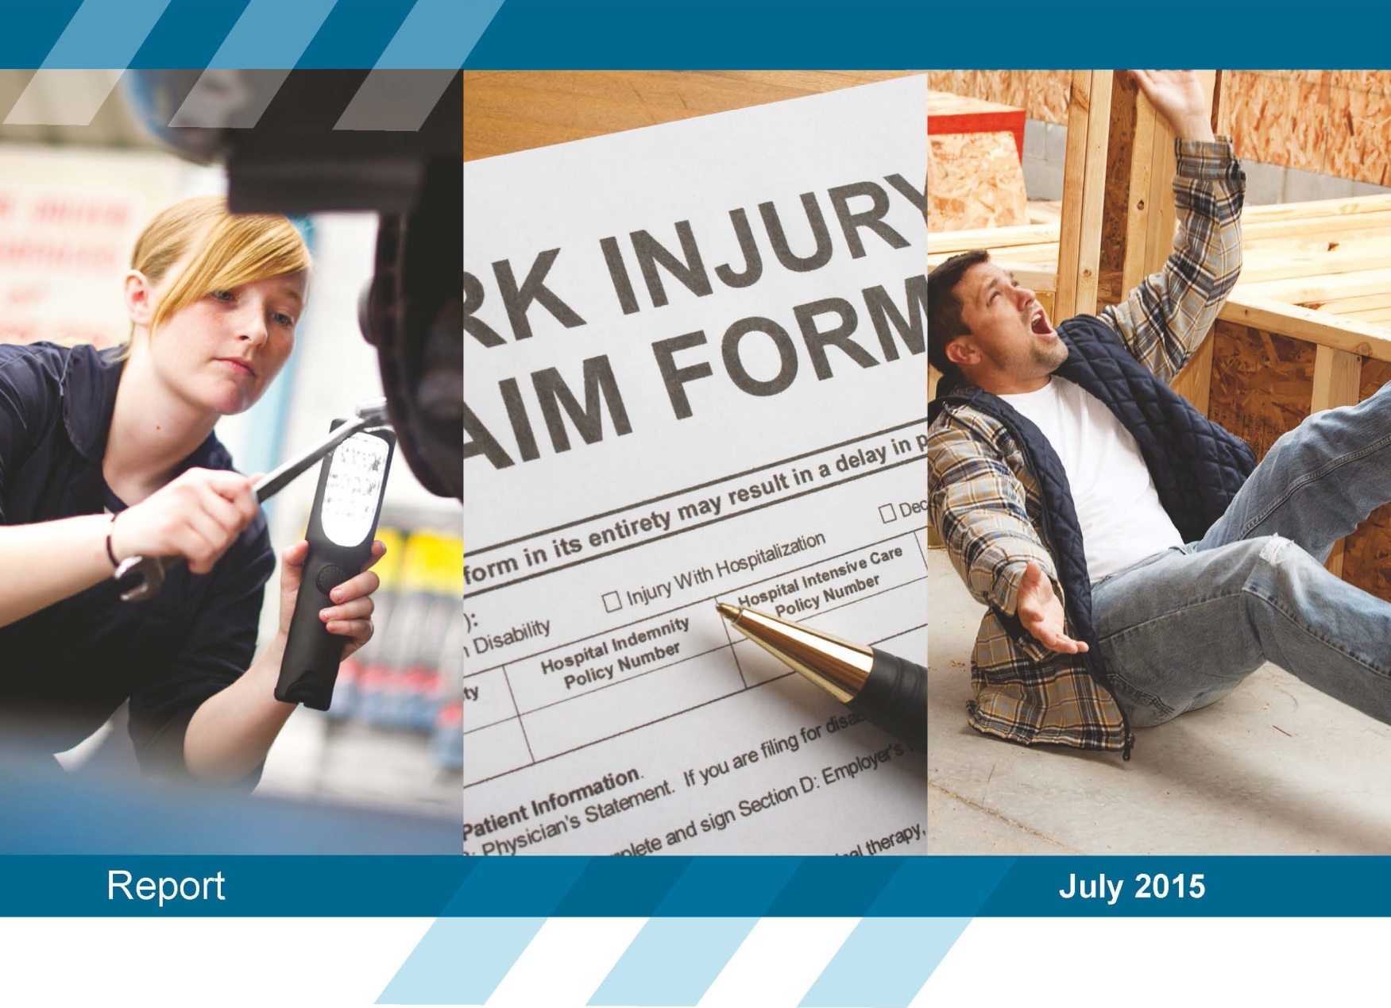
Disclaimer
The information provided in this document can only assist you in the most general way. This document does not replace any statutory requirements under any relevant state and territory legislation. Safe Work Australia is not liable for any loss resulting from any action taken or reliance made by you on the information or material contained in this document. Before relying on the material, users should carefully make their own assessment as to its accuracy, currency, completeness and relevance for their purposes, and should obtain any appropriate professional advice relevant to their particular circumstances.
To the extent that the material on this document includes views or recommendations of third parties, such views or recommendations do not necessarily reflect the views of Safe Work Australia or indicate its commitment to a particular course of action.
Creative Commons
ISBN 978-1-76028-224-0 [Online pdf ]
ISBN 978-1-76028-225-7 [Online doc ]
With the exception of the Safe Work Australia logo, this report is licensed by Safe Work Australia under a Creative Commons 3.0 Australia Licence. To view a copy of this licence, visit http://creativecommons.org/licenses/by/3.0/au/deed.en
In essence, you are free to copy, communicate and adapt the work, as long as you attribute the work to Safe Work Australia and abide by the other licensing terms.
Suggested citation:
Safe Work Australia (2015). Mindfulness of work health and safety in the workplace. Canberra: Safe Work Australia.
Enquiries regarding the licence and any use of the report are welcome at:
Copyright Officer
Safe Work Australia
GPO Box 641 Canberra ACT 2601
Email: copyrightrequests@safeworkaustralia.gov.au

Contents
Executive Summary 1
The Study 3
Main findings 7
References 28
Appendix 29

Preface
The Australian Work Health and Safety Strategy 2012-2022 (the Australian Strategy) seeks to explore the action area of Leadership and culture: Leaders in communities and organisations promote a positive culture for health and safety.
This report summarises findings from the Perceptions of Work Health and Safety Survey 2012 in terms of mindfulness (the conscious awareness) of work health and safety for Australian businesses and Australian workers. The report presents this information with regard to worker type, business size, occupation and industry.
Conducting and publishing research to inform the development and evaluation of work health and safety policies is a function of Safe Work Australia as per the Safe Work Australia Act 2008 (Cwlth). This research report was written to inform the development of polices in relation to the conscious awareness of work health and safety of Australian workers, employers and sole traders. The views and conclusions expressed in this report do not necessarily reflect the views of Safe Work Australia Members.
Perceptions of Work Health and Safety Survey 2012
This report presents responses from a survey questionnaire that were weighted to reflect the size, primary location and main industry of businesses in Australia. As is often the case with large surveys, the response rate was low. This increases the risk that the views and experiences of the study sample are biased and affects the extent to which those views and experiences can be generalised to the population of interest. In short, the survey provides potentially valuable information from 520 sole traders, 1052 employers and 1311 workers but we cannot be confident that the information is representative of the whole population. It is therefore important that estimates or comparisons, particularly those based on the relatively small number of medium-sized and large businesses, are seen as indicative or suggestive rather than representative or definitive.
As with all statistical reports, the potential exists for minor revisions over time.

Executive Summary
  - Background
How aware workers are of factors in their workplace that may impact work health and safety has been identified as an area of interest in the Australian Work Health and Safety Strategy 2012-22 (the Australian Strategy) under the action area of Leadership and culture: Leadership in communities and organisations to promote a positive culture for health and safety.
In the context of work health and safety, mindfulness is the conscious awareness of factors that affect or may affect work health and safety. This report will examine three aspects of organisational mindfulness with regard to work health and safety as measured by three sets of questions. These are: What businesses count on; sensitivity to operations; and preoccupation with failure.
In accordance with the national priority industries identified in the Australian Strategy which require the greatest improvement in relation to reducing incidence of deaths and/ or injuries, this report will focus on mindfulness in the following industries:
- Agriculture
- Road transport
- Manufacturing
- Construction
- Accommodation & food services
- Public administration & safety, and
- Health care & social assistance.
Further information on these priority industries can be found on the Safe Work Australia website.
Perceptions of Work Health and Safety Survey 2012
The Perceptions of Work Health and Safety Survey aimed to provide a national baseline measure of work health and safety attitudes, beliefs and actions shortly after the model Work Health and Safety laws were introduced. The survey targeted four types of respondents: employers, sole traders, health and safety representatives and workers.
  - Main findings
Across the three measures of mindfulness
Overall there were generally high levels of mindfulness across worker groups in terms of what businesses count on, sensitivity to operations and preoccupation with failure. Differences were present according to industry and occupation groups across the worker types.
Employers operating in the Health care and social assistance industry tended to have the lowest levels of mindfulness in terms of what they count on in their business, preoccupation with failure and sensitivity to operations compared to the other priority industries. Of particular note, less than half of these employers indicated that their business spends time identifying how its activities could potentially harm their workers (45%) compared to around 80% among the other priority industries. Sole traders working as Labourers displayed high levels of mindfulness across the three measures.
What businesses count on
The vast majority of employers and sole traders agreed that they knew what they don’t want to go wrong and what could go wrong within the workplace, and that everyone felt accountable for safety. Less than half of employers and one-third of sole traders indicated that they worried about misidentifying or misunderstanding potential causes of harm.
Preoccupation with failure
While businesses and workers all had high levels of agreement that when something unexpected occurs they always try to figure out why things didn’t go as expected, agreement was generally much lower for businesses actively looking for failures and trying to understand them. Employers in Manufacturing, Transport, postal and warehousing and Construction and sole traders in Manufacturing appeared to support both proactive and reactive approaches to work health and safety failures. Workers in these industries tended to favour the reactive approach.
While less than a third of workers agreed that their managers actively seek out bad news, the majority of workers agreed that workers are encouraged to report significant mistakes and are encouraged to talk to superiors about problems.
Sensitivity to operations
The majority of employers and sole traders agreed that their workplaces were sensitive to work health and safety operations, such as making sure there was always someone paying attention to what is happening. Fewer sole traders than employers agreed that they had a range of solutions whenever unexpected surprises cropped up.
Employers operating in the Accommodation and food services, Transport, postal and warehousing and Construction industries displayed consistently high levels of mindfulness with regard to sensitivity to operations in their workplace. This suggests that employers in these industries are very aware of small events within the workplace and how these can lead to more substantial problems. For example, supervisors are prepared to pitch in whenever necessary and should problems occur, someone with the authority to act is always accessible to the workers.
  - Disclaimer
This research report was written to inform the development of polices in relation to awareness of work health and safety in Australian businesses and among workers. The views and conclusions expressed in this report do not necessarily reflect the views of Safe Work Australia Members.

The Study
  - Rationale
Having an indication of how consciously aware (mindful) businesses, employers and workers are of work health and safety in their organisational environment provides valuable insights into individual and cultural factors influencing safety in the workplace that we may not have had previous knowledge of. This report provides policy makers with information from which policies and procedures can be developed to address lower levels of conscious awareness of work health and safety among certain groups of workers or in certain industries.
  - Approach
Perceptions of Work Health and Safety Survey 2012
The Perceptions of Work Health and Safety Survey collected information on awareness of work health and safety responsibilities and law changes, awareness of workplace risks, due diligence in undertaking activities to eliminate or minimise risks, and work health and safety communication, consultation and attitudes. The project’s broader ongoing aim is to examine the changes that have occurred in the health and safety performance of Australian workplaces since the introduction of the model legislation and to determine why these changes have occurred.
The survey involved four groups of respondents: businesses that employed workers, businesses that did not employ other people (sole traders or partnerships working in their own premises or in others’ premises), people who were employed and were either a Health and Safety Representative or Work Health and Safety Professional (HSR/ WHSP) and people in paid employment (excluding self-employed). A different questionnaire was designed for each of the respondent groups.
The survey of businesses collected completed surveys from 1052 employers and 520 sole traders and the survey of workers collected completed surveys from 1311 workers and 669 HSRs/ WHSPs across Australia. To create a nationally representative sample, the responses for sole traders, employers and workers were weighted to produce estimates of the number of businesses and workers within Australia that hold particular views about work health and safety. See Appendix A for further information on the survey methodology and demographic information.

Mindfulness
Mindfulness is a psychological state in which individuals engage in active information processing while performing their current tasks (Krieger, 2005). Mindfulness is defined as ‘a rich awareness of discriminatory detail and a capacity for action’ (Weick and Sutcliffe, 2006; Weick and Sutcliffe, 2007) and in an organisational context increases as people become more conscious about the ways in which the system can be disrupted, what might go wrong, and who these disruptions are likely to harm (Weick and Sutcliffe, 2007).
In the context of work health and safety, mindfulness is the conscious awareness of factors that affect or may affect work health and safety.
In high-reliability organisations where continual exposure to potential crises means that their next failure could be catastrophic (e.g. Air traffic control), mindfulness is focused on the clear comprehension of emerging threats and on factors that can interfere with this comprehension (Weick & Sutcliffe, 2006). These organisations spend more time (Weick & Sutcliffe, 2006, pp 516):
- examining failure as a window on the health system
- resisting the urge to simplify assumptions about the world
- observing operations and their effects
- developing resilience to manage unexpected events, and
- locating local expertise and creating a climate of deference to those experts.

Studies have shown that high reliability organisations utilise mindfulness in order to mitigate the potential for disasters. In a study of aviation crisis management, Krieger (2005) conducted a qualitative study of 10 aviation student dyads in a decision-making crisis situation to determine whether shared mindfulness (shared conscious awareness) would lead to more effective pilot decisions. Krieger (2005) found that students demonstrating more communication behaviours of shared mindfulness made the most effective decisions in the crisis situation.

A more recent study by Issel and Narasimha (2007) investigated ways for community-based health improvement initiatives to avoid failures with regard to client outcomes. This study looked specifically at a US federally funded health initiative to reduce infant mortality and pre-term birth, utilizing the mindfulness framework developed by Weick and Sutcliffe (2001), over a five year period. Mindlessness actions occurred at both federal and local levels, despite the possibility of enacting mindfulness strategies at federal and local levels (Issel and Narasimha, 2007, p 166). This led the authors to suggest that mindfulness strategies (strategies to increase levels of conscious awareness during neonatal care) could be used to minimise failures in health care initiatives.
  - The report
Major accidents can frequently be traced to failures in safety management systems (Hopkins, 2002). Given that mindfulness appears to minimise failures in organisations such as Air traffic control, and may prevent failure that can cause harm, mindfulness with regard to work health and safety may help to reduce incidents and injuries. This report is intended to provide observations of levels of mindfulness in Australian business and set the scene for further investigation.
This report will be structured according to the three mindfulness measures asked of employers, sole traders and workers. A final comparison section is included to allow for comparison across worker groups where the same question has been asked across the groups.
In order to explore mindfulness within the work health and safety context, the Perceptions of Work Health and Safety Survey included three scales of mindfulness inspired by those developed by Weick and Sutcliffe (2007) (See Appendix A). Each of these three scales were measured on a 5-point Likert scale ranging from Strongly disagree (1) to Strongly agree (5). Higher levels of agreement indicate higher levels of mindfulness. These scales are designed to assess mindfulness at the organisational level. The three scales of mindfulness are:
What businesses count on
Weick and Sutcliff (2007) describe this scale as a starting point for assessing a firm’s mindfulness. Responses to these items provide insight into whether people are conscious of potential problems and how open they are to finding out (Weick and Sutcliffe, 2007). Mindfulness increases as people become more conscious about the ways in which the system can be disrupted, what might go wrong, and who these disruptions are likely to harm (Weick and Sutcliffe, 2007).
Preoccupation with failure
A preoccupation with failure within a mindful organisation is not an unhealthy single-minded obsession with failure, but a healthy alertness and lively awareness of the possibility of errors and failures within the organisation (Khan, Lederer and Mirchandani, 2013). Responses to these items probe the degree to which an organisation has a healthy preoccupation with failure and whether small failures are noticed (Weick and Sutcliffe, 2006; Weick and Sutcliffe, 2007). These items also assess the degree to which people are aware of mindfulness as a desirable outcome and of how it can be operationalised (Weick and Sutcliffe, 2007).
Sensitivity to operations
Sensitivity to operations implies that a mindful organisation pays vigilant attention to each and every detail regardless of how seemingly insignificant it may be in day-to-day operations at a given moment (Khan, Lederer and Mirchandani, 2013). Diagnosing sensitivity to operations with these items can help to appraise how prepared a worker is to avert the accumulation of small events that can grow into bigger problems (Weick and Sutcliffe, 2007). Being sensitive to operations is a unique way to correct failures of foresight (Weick and Sutcliffe, 2007).
  - Limitations
A limitation of this study is that it relies on self-reported data and the findings presented in this report are based on people’s perceptions. The levels of mindfulness nominated by survey respondents may differ from the actual levels of mindfulness when at work.
Surveys such as the Work Health and Safety Perceptions Employer Survey and the Health and Safety at Work Survey were professionally sampled using the best available sampling frame to ensure representative data but some response bias cannot be discounted. As such, the findings should be taken as indications only and not as statistically significant differences between groups. Findings presented by business size should be taken only as indicative, particularly for medium and large businesses as a high proportion of the survey respondents were small businesses. However, the substantial number of surveys completed for these surveys means that responses do provide an indication of work health and safety perceptions and practices and baseline data for comparison with follow-up surveys.
Mindfulness is complex psychological state that likely requires a much more in depth introduction than this report is able to provide. Mindfulness promotes an approach to the present that is more inclusive and authentic, and provides the opportunity to ‘slow down’ and observe the full range of our experiences as they truly are (Marianetti & Passmore, 2009). On an individual level, research shows that when practiced regularly, mindfulness can improve memory, motivation, creativity and job satisfaction among other psychological and physiological factors (Marianetti & Passmore, 2009). For further reading on mindfulness for both individual and organizational contexts, see Marianetti & Passmore (2009).
The report covered a large amount of information available while attempting to be as concise as possible. As such some of the findings and conclusions may appear too simplistic.
  - Results preamble
Due to the qualitative nature of the findings, there are no accompanying statistics such as confidence intervals to indicate the reliability of estimates or inferences.

Main findings
  - Employers
What businesses count on
The majority of employers (88%) agreed that in their business everyone feels accountable for safety. The majority of employers (84%) also agreed that in their business there is widespread agreement on what they don’t want to do wrong, with three quarters also agreeing that there is widespread agreement about how things could go wrong.
Less than half of employers indicated that their business worries about misidentifying (44%) and misunderstanding (43%) the causes of work incidents and injuries.

Business size
Figure 1 shows that there were some differences across business sizes for employers. Small and medium business employers (88% and 87%) were slightly more likely to agree that everyone feels accountable for safety than employers in large businesses (73%). Almost all large business employers agreed that their business spends time identifying how their activities could potentially harm their workers, compared to 85% of medium business employers and 71% of small business employers.
Small business employers were less likely to agree that there was widespread agreement in their business about how things could go wrong (73%) and what they don’t want to go wrong (82%) compared to medium (87% and 95%) and large (85% and 94%) businesses.
Figure 1: Mindfulness – what businesses count on by business size
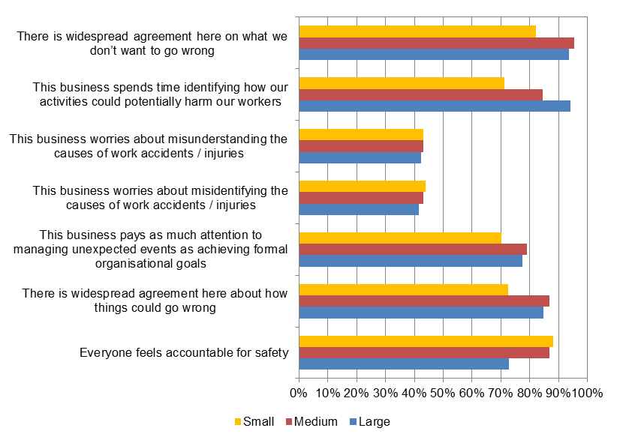

Industry
Figure 2 shows a number of interesting findings, including:
- Almost all employers operating in the Agriculture, forestry and fishing, Manufacturing and Accommodation and food services industries agreed that everyone in their workplace feels accountable for safety.
- Employers operating in the Manufacturing and Transport, postal and warehousing industries tended to display consistently high levels of mindfulness with regard to what they count on in their business. Specifically, while displaying high levels of agreement along with other priority industries with a number of the questions included on this scale, the Manufacturing and Transport, postal and warehousing industries had much higher levels of agreement for the business worrying about misunderstanding and misidentifying the causes of work incidents/ injuries.
- Employers operating in Health care and social assistance tended to display the lowest levels of mindfulness in terms of what they count on in their business, with less than half indicating that their business spends time identifying how its activities could potentially harm their workers (45%) and that their business pays as much attention to managing unexpected events as achieving formal organisational goals (48%).
Figure 2: Mindfulness – what businesses count on by industry*
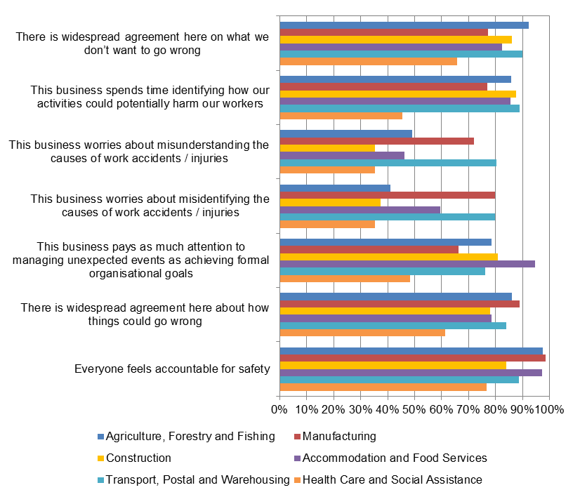
* Public administration and safety not shown due to very small numbers of survey respondents.
Preoccupation with failure
The majority of employers (87%) agreed that when something unexpected occurs, they always try to figure out why things didn’t go as expected. However, about two thirds (65%) of employers agreed that their business actively looks for failures of all sizes and tries to understand them. This suggests that employers have a reactive approach to failures of work health and safety as opposed to a preventative, proactive approach.
While employers indicated that managers typically did not seek out bad news (37% agreement), the majority of employers (85%) did agree that workers are encouraged to report significant mistakes even if others do not notice a mistake is being made and that workers are encouraged to talk to superiors about problems (87%). Just over one third of employers (35%) agreed that workers are rewarded if they spot potential trouble spots in their workplace.

Business size
Figure 3 shows that employers in small businesses generally had lower levels of mindfulness with regard to preoccupation with failure. These differences were greatest for the business often updating procedures after experiencing a near miss (58% compared to 82% for medium and large) and for the business actively looks for failures of all sizes and tries to understand them (63% compared to 78% medium and 75% large).
Almost all large (99%) and medium (98%) businesses agreed that when something unexpected occurs, they always try to figure out why things didn’t go as expected while 85% of small business employers agreed with this statement.
Figure 3: Mindfulness – employer preoccupation with failure by business size
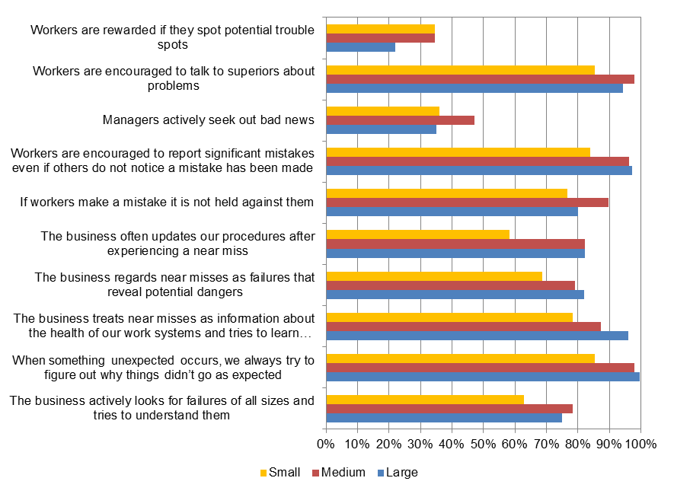

Industry
Figure 4 shows that employers operating in the Health care and social assistance industry tended to have lower levels of mindfulness relating to preoccupation with failure compared to the other priority industries. The greatest differences were observed for:
- the business often updates our procedures after experiencing a near miss (40% agreement)
- the business regards near misses as failures that reveal potential dangers (58%), and
- the business treats near misses as information about the health of our work systems and tries to learn from them (68%).
Manufacturing and Transport, postal and warehousing employers were generally among the industries with the highest levels of mindfulness as reflected by preoccupation with failure items compared to the other priority industries.
While employers operating in Accommodation and food services generally had high levels of agreement with the preoccupation with failure items, low levels of agreement were observed compared to other industries in relation to the items:
- the business actively looks for failures of all sizes and tries to understand them (34%), and
- workers are rewarded if they spot potential trouble spots (8%).
Figure 4: Mindfulness – employer preoccupation with failure by industry
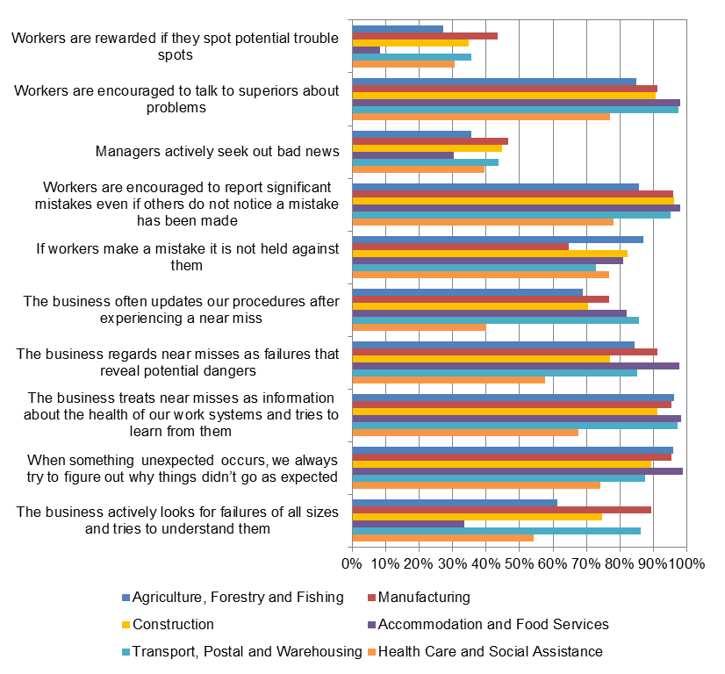
* Public administration and safety not shown due to very small numbers of survey respondents.
Sensitivity to operations
The majority of businesses appear sensitive to operations and ensure that work health and safety risks can be capably managed within the workplace. Almost all employers (95%) indicated that should problems occur in their workplace, someone with the authority to act is always accessible to workers and on a day to day basis, there is always someone who is paying attention to what is happening in the workplace (91%). Just under three quarters of employers (73%) agreed that people are familiar with operations beyond their own job.

Business size
Figure 5 shows that small business employers were slightly more likely to indicate that people in their workplace are familiar with operations beyond their own job (74%) compared to employers in medium and large businesses (66% and 61%). Large business employers were much less likely to agree that workers have discretion to resolve unexpected problems as they arise than employers in medium and large businesses (66% compared to 95% and 87%). Large business employers were also much less likely to agree that the business constantly monitors workloads and reduces them when they become excessive compared to medium and small businesses (61% compared to 87% and 76%).
Figure 5: Mindfulness – employer sensitivity to operations by business size
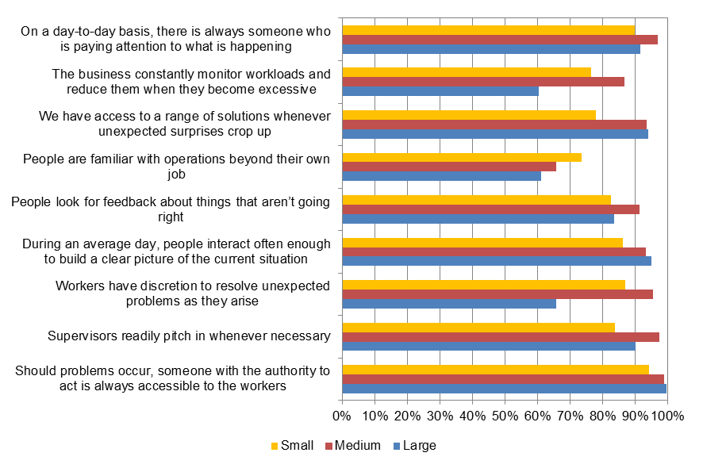

Industry
Figure 6 shows that all employers operating in Manufacturing, Construction and Accommodation and food services (and 99% in Transport, postal and warehousing) agreed that should problems occur, someone with the authority to act is always accessible to the workers. Other findings of interest include:
- Employers operating in Accommodation and food services were more likely to agree that workers have discretion to resolve unexpected problems as they arise (100%), that people look for feedback about things that aren’t going right (99%) and that people are familiar with operations beyond their own job (98%) compared to the other priority industries.
- Almost all employers operating in Transport, postal and warehousing agreed that supervisors readily pitch in whenever necessary and during an average day, people interact often enough to build a clear picture of the current situation (99% and 98%). This was also higher than the level of agreement observed for the other priority industries (with the exception of the construction industry).
- Nearly all Construction employers (94%) indicated that their business constantly monitors workloads and reduces them when they become excessive, while 90% of construction employers agreed that they have access to a range of solutions whenever unexpected surprises crop up. These levels of agreement were higher than those observed for the other priority industries.
Figure 6: Mindfulness – employer sensitivity to operations by industry
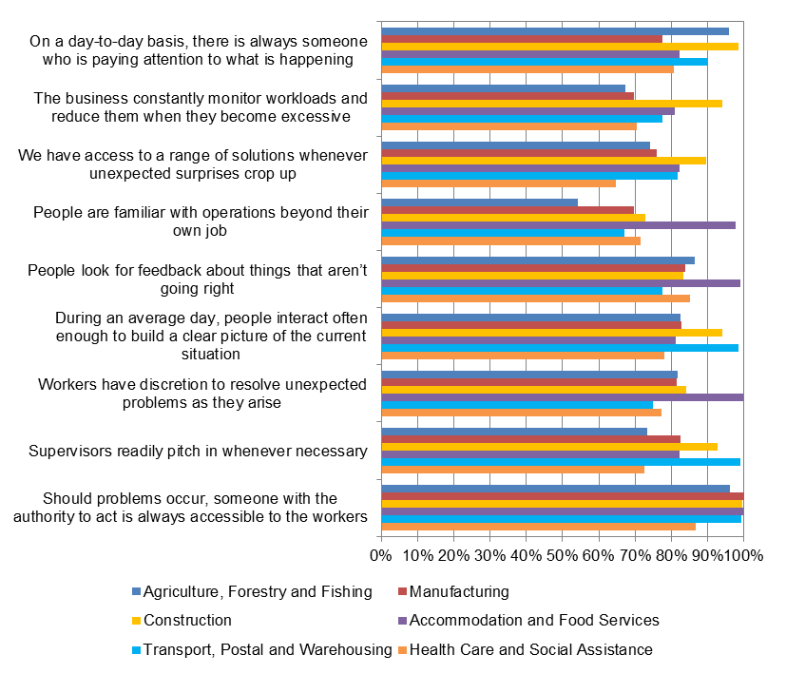
* Public administration and safety not shown due to very small numbers of survey respondents.

  - Sole traders
What businesses count on
The majority of sole traders indicated that they are clear about how things could go wrong in their business (86%) and that they are clear on what they don’t want to go wrong in their business (84%). Just over two thirds (69%) of sole traders agreed that they spend time identifying how their work activities could potentially harm others. Less than a third of sole traders agreed that they worry about misidentifying (30%) and misunderstanding (28%) the causes of work incidents/ injuries in their workplaces.

Industry
Figure 7 shows that sole traders operating in Accommodation and food services and Transport, postal and warehousing were generally more mindful in terms of what they count on in their business. The exception for Accommodation and food services was agreement with ‘I pay as much attention to managing unexpected events as I do to achieving other business goals’ where these sole traders had the third highest level of agreement (62%).
Sole traders operating in Accommodation and food services and Transport, postal and warehousing were particularly concerned about injuries and incidents occurring in their workplaces. Seventy one percent of sole traders in Accommodation and food services indicated they worry about misunderstanding and misidentifying the causes of work incidents/ injuries, followed by 62% and 63% for sole traders operating in Transport, postal and warehousing. This was much higher than that observed for the other priority industries.
Figure 7: Mindfulness – what sole traders count on by industry*
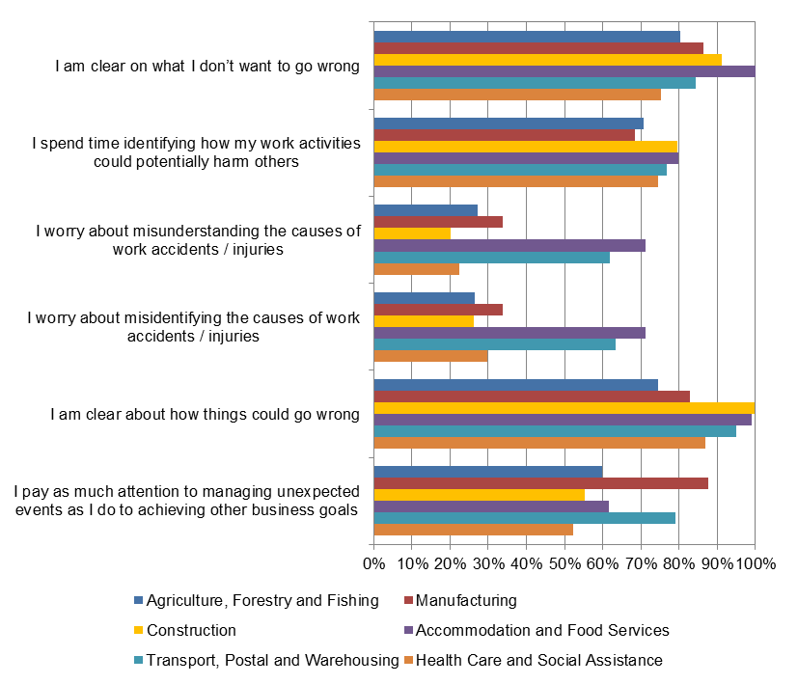
* Public administration and safety not shown due to very small numbers of survey respondents.

Occupation
Figure 8 shows that generally the more ‘hands on’ occupation groups were mindful in terms of what they can count on with regard to work health and safety. Specifically:
- almost all Machinery operators and drivers (97%) agreed that they pay as much attention to managing unexpected events as they do to achieving other business goals – much higher than the other occupation groups
- almost all Technicians and trades workers (94%), Machinery operators and drivers and Labourers (98% each) agreed that they were clear about how things could go wrong in their work, with similarly high proportions of agreement regarding that they are clear on what they don’t want to go wrong while working (Labourers 98%; Machinery operators and drivers and Technicians and trades workers 90% each), and
- Machinery operators and drivers and Labourers were also more likely to agree that they spend time identifying how their work activities could potentially harm others (90% and 87%) and worry about misunderstanding (54% each) and misidentifying (51% and 54%) the causes of work incidents and injuries in comparison with the other occupation groups.
Clerical and administrative workers had a much lower level of agreement with spending time identifying how their work activities could potentially harm others in comparison with the other occupation groups. Given these findings, it is possible that these ‘hands on’ occupation groups are more mindful due to there being a greater inherent risk of injury in terms of the tasks they commonly perform.
Figure 8: Mindfulness – what sole traders count on by occupation*
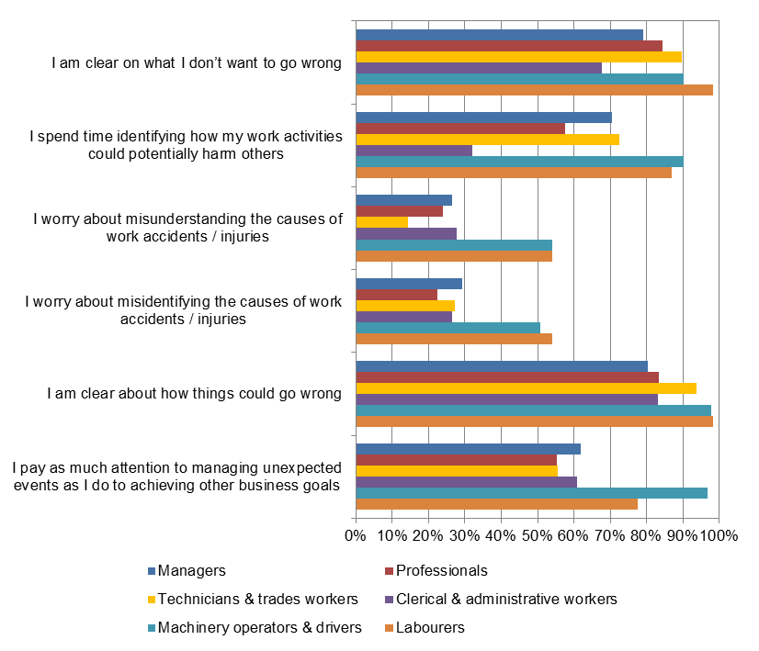
* Community and personal service workers and sales workers not shown due to very small numbers of survey respondents.
Preoccupation with failure
Most (84%) sole traders agreed that when something unexpected occurs they always try to find out why things didn’t go as expected. Almost three quarters of sole traders (71%) also agreed that they treat near misses as information about the health and safety of their work systems and try to learn from them. This compares to just over half (57%) of sole traders agreeing that they actively look for failures of all sizes and try to understand them and 55% agreed that they often update their procedures after experiencing a near miss.
For work completed by sole traders outside of their workplace 71% agreed that they don’t get into trouble if they report problems that might stop operations, with 67% agreeing that they report near misses that might have serious consequences even if no one sees them.

Industry
Figure 9 shows a number of interesting findings, including:
- all sole traders operating in the Manufacturing and Accommodation and food services and almost all in Construction (99%) industries agreed that when something unexpected occurs they always try to figure out why things didn’t go as expected
- these industries also had corresponding high levels of agreement with treating near misses as failures that reveal potential dangers (rather than as successes that show my capability to avoid disaster) and I treat near misses as information about the health of my work systems and try to learn from them
- while most (86%) Manufacturing sole traders agreed that they often update their procedures after experiencing a near miss, Accommodation and food services and Construction sole traders were less likely to agree (59% and 56% respectively), and
- despite sole traders operating in these industries indicating that they try to figure out unexpected events, treat near misses as a source of information and regard near misses as failure that reveal possible dangers, only those operating in the Manufacturing industry agreed that they actively look for failures and try to understand them (99%), whereas only 60% of those operating in Accommodation and food services and 51% operating in construction agreed with this statement.

Taken together these findings could indicate reactivity to work health and safety issues rather than proactively trying to solve them.
When working in a workplace other than their own, almost all sole traders operating in the Manufacturing industry agreed that they don’t get into trouble if they report problems that may stop operations (99%), followed by 83% in Health care and social assistance and 81% in Construction.

Figure 9: Mindfulness – sole trader preoccupation with failure by industry**

* Asked of sole traders working outside of their workplace.
** Public administration and safety not shown due to very small numbers of survey respondents.

Occupation
Figure 10 shows that:
- sole traders operating as Clerical and administrative workers had the lowest levels of mindfulness with regard to preoccupation with failure of all occupation groups shown. Levels of agreement were particularly low for actively looking for failures of all sizes and trying to understand them (21%) and updating procedures after experiencing a near miss (17%)
- almost all Labourers agreed that when something unexpected occurs they always try to figure out why things didn’t go as expected (98%) and that they treat near misses as information about the health and safety of their work systems and try to learn something from them (97%)
- when working outside their workplace around three quarters of Machinery operators and drivers, Labourers and Managers agreed that they report near misses that might have serious consequences even if no one sees them (79%, 77% and 74% respectively). Clerical and administrative workers were much less likely to agree that they don’t get into trouble if they report problems that might stop operations (35%) compared to the other occupation groups shown.

Figure 10: Mindfulness – sole trader preoccupation with failure by occupation
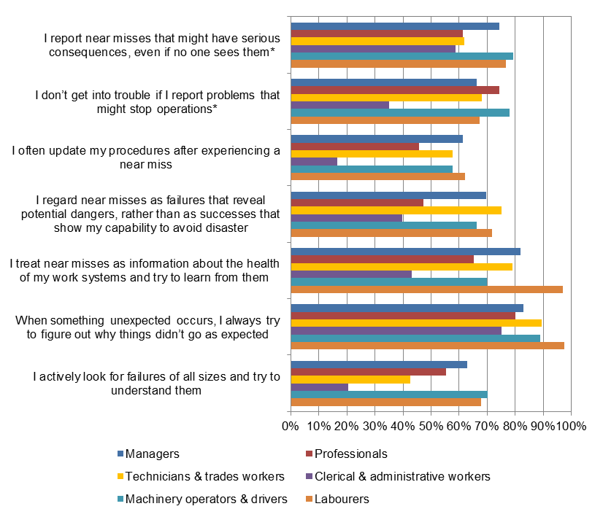
* Community and personal service workers and sales workers not shown due to very small numbers of survey respondents.
Sensitivity to operations
The majority of sole traders (85%) agreed that on a day to day basis they are always paying attention to what is happening during their work. Less than two thirds agreed that they have access to a range of solutions whenever unexpected surprises crop up (61%) and that they constantly monitor workloads and reduce them when they become excessive (60%).

Industry
Figure 11 shows a number of findings, including:
- all sole traders operating in Accommodation and food services agreed that on a day to day basis they are always paying attention to what is happening, followed by 90% of sole traders operating in the Construction industry
- sole traders operating in the Construction industry had the highest level of agreement that they have access to a range of solutions whenever unexpected surprises crop up (73%), while sole traders operating in Transport, postal and warehousing had the lowest (50%), and
- sole traders in Accommodation and food services were the most likely to agree that they constantly monitor workloads and reduce them when they become excessive (78%), followed by sole traders in Transport, postal and warehousing and construction (71% and 68% respectively). Sole traders in Health care and social assistance had the lowest level of agreement.
Figure 11: Mindfulness – sole trader sensitivity to operations by industry
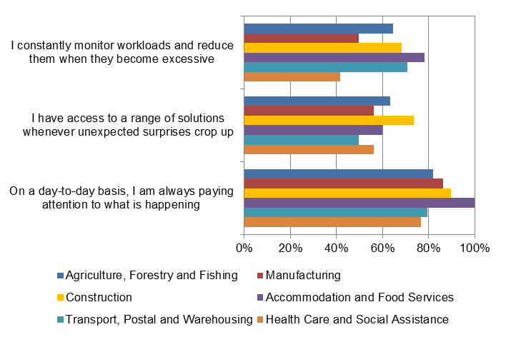
* Public administration and safety not shown due to very small numbers of survey respondents.

Occupation
Figure 12 shows that Labourers had the highest level of mindfulness in relation to sensitivity to operations. Almost all Labourers (98%) indicated that on a day to day basis they are always paying attention to what is happening, followed by 89% of Technicians and trades workers and 88% of professionals. Labourers were also more likely to agree that they have access to a range of solutions whenever unexpected surprises crop up (79%) compared to the other priority industries.
Clerical and administrative workers were least likely to agree that they constantly monitor workloads and reduce them when they become excessive, while Labourers and Machinery operators and drivers were the most likely to agree (95% and 88% respectively).

Figure 12: Mindfulness – sole trader sensitivity to operations by occupation
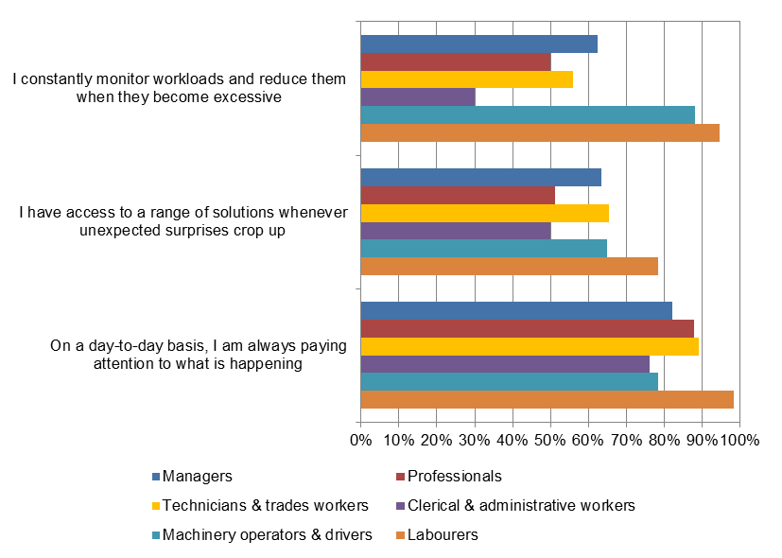
* Community and personal service workers and sales workers not shown due to very small numbers of survey respondents.

  - Workers
Preoccupation with failure
Just over half of workers (57%) indicated that people in their workplace actively look for failures of all sizes and try to understand them. Despite this, most workers (88%) agreed that when something unexpected occurs people always try to figure out why things didn’t go as expected. The majority of workers (83%) also agreed that near misses are treated as information about the health of their work systems and people try to learn from them.
Around three quarters of workers correspondingly agreed that near misses are regarded as failures that reveal potential dangers (71%) and that procedures are updated after experiencing a near miss (75%). Three quarters of workers also agreed that if workers make a mistake it is not held against them (74%).
While less than a third (31%) of workers agreed that their managers actively seek out bad news, the majority of workers agreed that workers are encouraged to report significant mistakes even if others do not notice a mistake has been made (85%). While most workers agreed that workers are encouraged to talk to superiors about problems (88%), only a quarter of workers (24%) agreed that workers are rewarded if they report potential trouble spots.

Industry
Figure 13 indicates that overall, workers working in the Manufacturing and Transport, postal and warehousing industries generally displayed the highest levels of mindfulness in terms of preoccupation with failure. Other key findings include:
- two thirds of workers in the Construction and Transport, postal and warehousing industries agreed that people in their workplace actively look for failures of all sizes and try to understand them, followed by 60% in Agriculture forestry and fishing and 59% in Manufacturing
- workers in all industries (with the exception of Agriculture, forestry and fishing) had agreement levels above 80% for near misses being treated as information about the health of their work systems and people in the workplace try to learn from them. Manufacturing workers had the highest level of agreement (84%) for near misses being regarded as failures that reveal potential dangers; followed by workers in the Transport, postal and warehousing (75%) and Construction (71%) industries
- workers agreed that workers are encouraged to report significant mistakes and talk to supervisors about problems to a relatively high degree (all above 79% agreement), whereas agreement with managers actively seeking out bad news was much lower. Specifically, workers in the Construction, Accommodation and food services and Transport, postal and warehousing industries were more likely to agree that managers actively seek out bad news compared to the other priority industries (46%, 42% and 42% respectively), and
- agreement was again low for workers being rewarded if they report potential trouble spots, with workers in Accommodation and food services and transport postal and warehousing (33% and 29% respectively) industries more likely to agree compared to the other priority industries.

Figure 13: Mindfulness – worker preoccupation with failure by industry
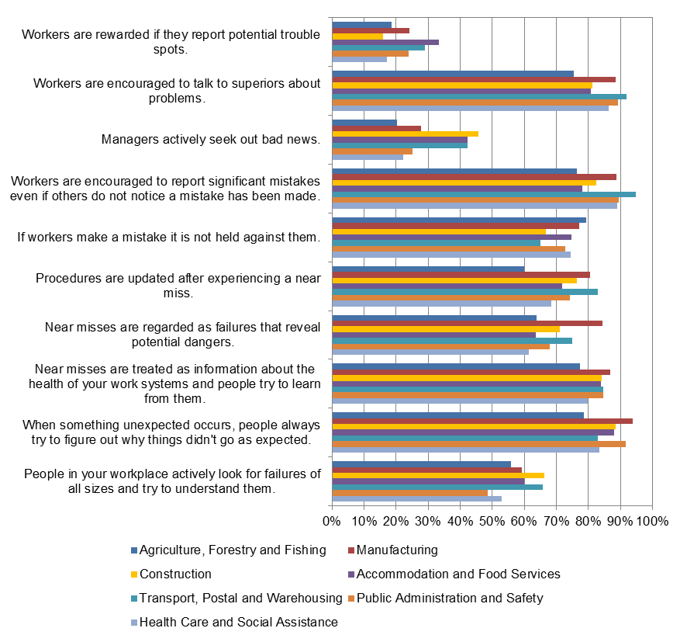

Occupation
Figure 14 shows a number of interesting findings, including:
- Machinery operators and drivers, Labourers and Technicians and trades workers were most likely to agree that people in their workplace actively look for failures and try to understand them (69%, 65% and 62% respectively) whereas less than half of Sales workers agreed (44%). Despite this, all occupation groups had 80% agreement or higher that when something unexpected occurs, people always try to figure out why things didn’t go as expected
- eighty three percent of Technicians and trades workers agreed that near misses are regarded as failures that reveal potential dangers, with 77% of Managers and 75% of Machinery operators and drivers and Labourers also agreeing with this statement
- eighty three percent of Machinery operators and drivers agreed that procedures are updated after experiencing a near miss followed by 79% of clerical and administrative workers and Technicians and trades workers
- all occupation groups (with the exception of Sales workers) had agreement levels over 80% in terms of workers being encouraged to report significant mistakes even if others do not notice a mistake has been made. Similarly high levels of agreement were observed for workers being encouraged to talk to supervisors about problems, with Managers having the highest level of agreement at 94% and Labourers having the lowest (79%), and
- nearly half (43%) of Machinery operators and drivers agreed that workers are rewarded if they report potential trouble spots, much higher than that observed for the other occupation groups.
Figure 14: Mindfulness – worker preoccupation with failure by occupation
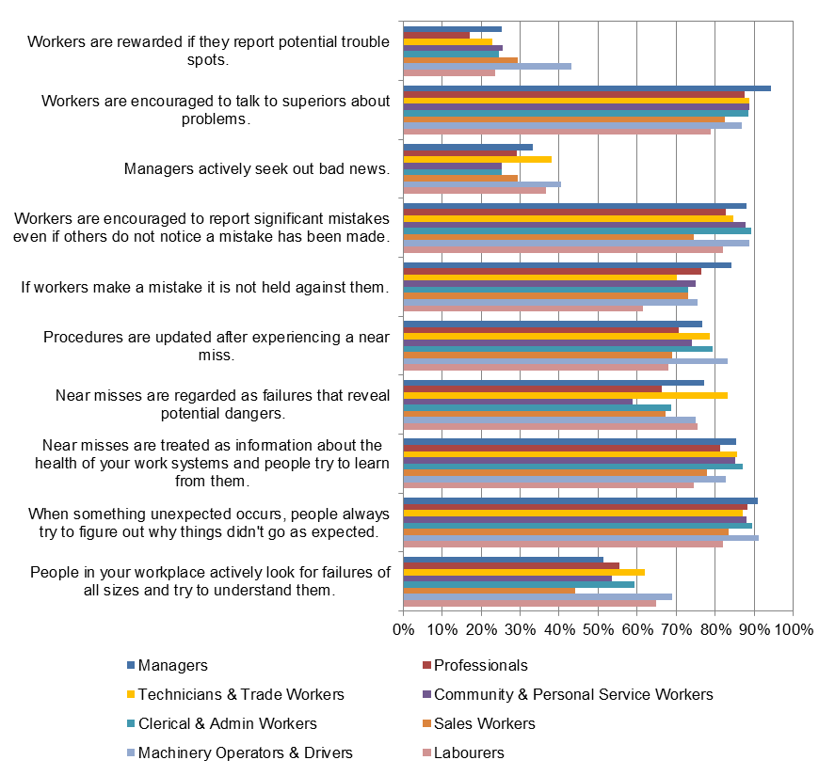

  - Comparing levels of mindfulness across worker type
This section compares responses on mindfulness items that were asked of more than one group in order to determine whether any differences exist.
What businesses count on
Figure 15 compares responses from Australian businesses (sole traders and employers) with regard to what they count on in their workplace in terms of work health and safety. Levels of agreement were identical in terms of there being widespread agreement on what they don’t want to go wrong (84% each), with similar levels of agreement with spending time identifying how activities could potentially harm workers (73% employers and 69% sole traders).
Sole traders were slightly more likely to agree that they are clear on what they don’t want to go wrong (86%) compared to employers (74%). In contrast employers were more likely to agree that their business worries about misidentifying and misunderstanding the cause of incidents and injuries (44% and 43%) compared to sole traders (30% and 28%).
Figure 15: Mindfulness – what businesses count on by sole traders and employers
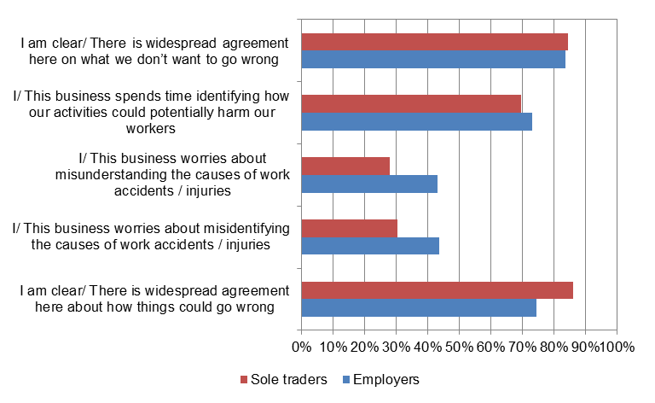
Preoccupation with failure
Figure 16 compares sole traders, employers and workers on a number of items from the preoccupation with failure scale and shows that sole traders had slightly lower levels of mindfulness overall while workers had slightly higher levels. Workers had a much higher level of agreement (75%) with the exception of the business often updates our procedures after experiencing a near miss than employers and sole traders (61% and 55% respectively). Employers also had a slightly higher level of agreement for the business actively looking for failures of all sizes and tries to understand them (65%) compared to workers and sole traders (57% each).
Figure 16: Mindfulness – preoccupation with failure by sole traders, employers and workers
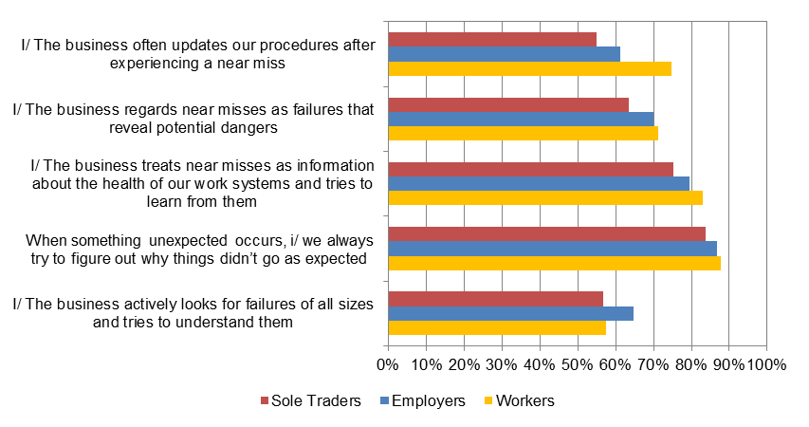
Figure 17 shows that employers and workers had almost identical agreement with workers being encouraged to report significant mistakes even if others do not notice a mistake has been made (85% each) and workers are encouraged to talk to superiors about problems (87% employers and 88% workers). Workers were slightly less likely to agree that managers actively seek out bad news (31%) compared to employers (37%) and less likely to agree that workers are rewarded if they report potential trouble spots (24% workers and 35% employers). This indicates that while workers are encouraged to look for and report potential problems they perceive that employers are less concerned with this.
Figure 17: Mindfulness – preoccupation with failure by employers and workers
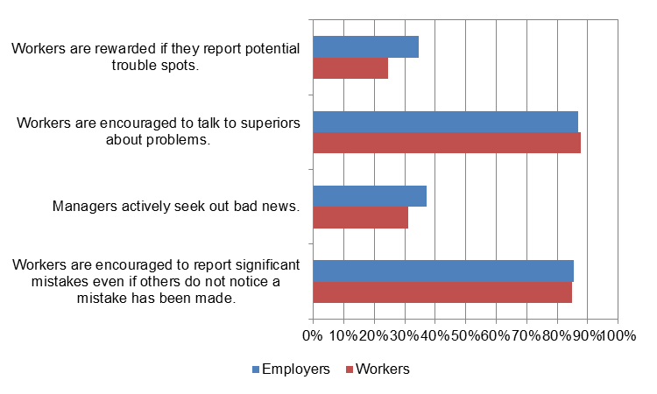
Sensitivity to operations
Figure 18 shows that employers tended to be more mindful in terms of sensitivity to operations than sole traders when it came to constantly monitoring workloads and reducing them when they become excessive (77% and 60%) and having access to a range of solutions whenever unexpected surprises crop up (80% and 61%). This may be related to businesses having greater resources available to be able to deal with these situations. Both groups had similarly high levels of agreement that on a day-to-day basis there is always someone who is paying attention to what is happening (85% sole traders and 91% employers).
Figure 18: Mindfulness – sensitivity to operations by sole traders and employers
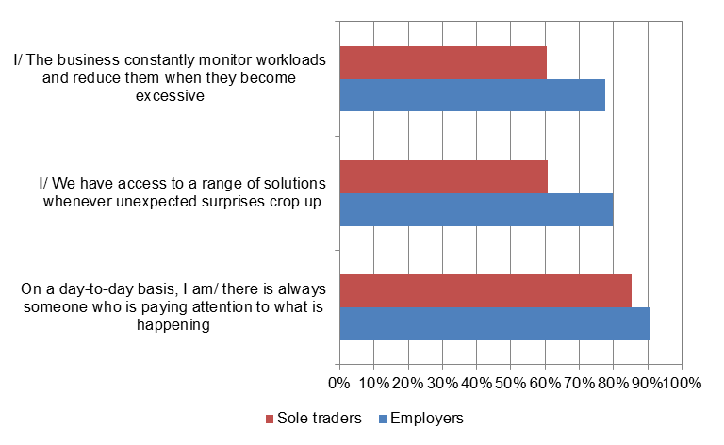

  - Conclusions
Across the three measures of mindfulness
While there are generally high levels of mindfulness among all groups, another study undertaken by Safe Work Australia has shown that the top two perceived causes of injury nominated by employers, sole traders and workers were ‘the worker being careless’ and ‘just not thinking’ (Safe Work Australia, 2015). In another study it was found that over 20% of sole traders and workers and just under 20% of employers agreed that they regarded risks as unavoidable in their workplace (Safe Work Australia, 2014a). One explanation for these seemingly divergent findings is positive bias associated with responding to the mindfulness items within the survey (i.e. wanting to promote a good impression by agreeing with items when this may not be the case in reality). Another explanation could be that while employers, sole traders and workers are generally quite mindful of work health and safety in their workplaces, they occasionally experienced failures in attention which lead to incidents occurring, or perhaps as a result of inherent risks existing in their workplaces from the nature of the work or the way in which it or the workplace is designed. Further research into the impediments to practical application of these general high levels of work health and safety awareness on a day-to-day basis to prevent workplace incidents and injuries would enable the establishment of an evidence base of the impact of conscious awareness of work health and safety on workplace incidents and injuries.
The comparatively low levels of mindfulness observed for employers within the Health care and social assistance industry is of concern. However, these findings could reflect that the work health and safety policies and procedures used in these workplaces do not allow for the regular assessment of potential failures or the updating of policies and procedures following a near miss. In addition, the positions held by workers in this industry may not allow for workers to solve unexpected problems or a range of solutions to be available is something unexpected occurs. Workers’ compensation claims data show that the health care and social assistance industry had the highest number of serious claims in 2012-13 (preliminary) of all industries, and that there has been a 29% increase in the number of serious claims over the period 2000-01 to 2011-12 (Safe Work Australia, 2014b). Investigation into work health and safety mindfulness in the Health care and social assistance industry, such as the system of work health and safety used and the nature and application of relevant policies and procedures used, may shed further light on patterns of workplace injury and illness in the industry.
The finding that sole traders working as Labourers had high levels of agreement across the three measures of mindfulness indicates that this ‘hands on’ occupation group appears more mindful of work health and safety in their workplace due to the inherent risk associated with their work or the greater potential consequences of failures. This finding is also in line with Labourers having the highest level of agreement that they never accept risk taking even if the work schedule is tight compared to other occupation groups (Safe Work Australia, 2014a).
Preoccupation with failure
A key theme that emerged from this study is that despite a high degree of mindfulness of work health and safety among Australian businesses and workers, there remains a tendency to approach work health and safety prevention reactively (such as treating a near miss as useful information) rather than proactively (such as spending time to actively look for possible failures). The favouring of a reactive approach to work health and safety incidents by Australian businesses is potentially an important insight into the ways in which Australian businesses manage work health and safety. This may be due to businesses not having the resources available to proactively assess their workplace for potential threats to safety (preventing incidents before they can happen), or this may simply not be a priority for businesses. A proactive approach to work health and safety does however appear to be undertaken within those priority industries that have relatively high inherent injury risk (such as Construction), suggesting that potentially catastrophic events may be proactively mitigated where they are most likely to occur. Workers’ compensation claims data show that the Construction and Manufacturing industries had the greatest decrease in incidence rates of the priority industries over the period 2000-01 to 2011-12, with Transport, postal and warehousing also experiencing a substantial decrease (Safe Work Australia, 2014). Generally, taking a largely proactive approach indicates a good level of mindfulness with regard to preoccupation with failure of work health and safety in the culture of these workplaces.
This study suggests that both parties – employers and workers – have high levels of mindfulness for work health and safety in accordance with their responsibilities under the model Work Health and Safety (WHS) laws with regards to ensuring the health and safety of workers and taking reasonable care of their own health and safety while at work. As the study found that the minority of managers seek out bad news with regard to work health and safety in their workplaces, while at the same time workers are encouraged to report problems and mistakes to a high degree, further investigation into how employers’ and workers’ carry out their duties under the model WHS laws would be of benefit.
Sensitivity to operations
This study suggests that employers in Accommodation and food services, Manufacturing and Construction are more mindful of work health and safety in terms of sensitivity to operations in their workplaces than other priority industries. This may be due to there being inherent risks associated with the work conducted in these industries, and the potential for catastrophic consequences, which may lead employers to be vigilant throughout all aspects of operations to ensure potential risks are reduced. Workers’ compensation data show that incidence rates of serious claims in these industries have decreased substantially over the period 2000-01 to 2011-12, with claim numbers dropping substantially for Manufacturing over the same period while Construction and Accommodation and food services remained stable (Safe Work Australia, 2014). This study suggests that high levels of mindfulness with regards to work health and safety, and specifically taking a more proactive approach towards risk management, may be contributing to recent reductions in accidents and injuries within these workplaces. However, this requires confirmation through further empirical study.

References
Issel, L. M. & Narasimha, K. M. (2007). Creating complex health improvement programs as mindful organizations: From theory to action. Journal of Health Organization and Management, 21 (2), pp 166-183.
Hopkins, A. (2002). Safety Culture, Mindfulness and Safe Behaviour: Converging ideas? Working Paper, National Research Centre for Occupational Health and Safety Regulation. Retrieved from: http://www.efcog.org/wg/ism_pmi/docs/Safety_Culture/Hopkins_safety_culture_converging_ideas.pdf
Krieger, J. L. (2005). Shared mindfulness in cockpit crisis situations: An exploratory analysis. Journal of Business Communication, 42 (2), pp 135-167.
Marianetti, O. & Passmore, J. (2009). Mindfulness at work: paying attention to enhance well-being and performance. In A. Lindley (ed.) Oxford Handbook of Positive Psychology and Work (pp189-200). Oxford, UK: Oxford University Press. Retrieved from: http://www.jonathanpassmore.com/resources/Mindfulness%20at%20work%20-%20Paying%20attention%20to%20enhance%20well-being%20and%20performance%202009.pdf
Weick, K.E. & Sutcliffe, K.M. (2006). Mindfulness and the quality of organizational attention. Organization Science, 17(4), pp 514-526.
Weick, K. E., & Sutcliffe, K. M. (2007). Managing the unexpected: Resilient performance in an age of uncertainty (Second Ed.). San Francisco: John Wiley & Sons, Inc.
Safe Work Australia (2014a). Risk taking and rule breaking in Australian workplaces.
Safe Work Australia (2014b). National Dataset for Compensation-based Statistics.
Safe Work Australia (2015). Perceived causes of work-related injuries and illnesses Australia (unpublished).

Appendix
  - Work Health and Safety Perceptions Sole Trader, Employer and Worker Surveys 2012
The Perceptions of Work Health and Safety Survey aimed to provide a national baseline measure of work health and safety attitudes, beliefs and actions shortly after the model WHS laws were introduced. The survey targeted four types of respondents: employers, sole traders, health and safety representatives and workers. There were four separate questionnaires tailored for the four types of respondents. All four questionnaires covered similar themes and questions.
Work Health and Safety Perceptions Employer and Sole Trader Survey 2012
The employer survey was a paper based survey, conducted from October 2012 to January 2013. A random sample of 10 000 employing businesses were drawn by the Australian Bureau of Statistics for this survey and the same sample was used for the survey of sole traders. The sample took into account the number of businesses in each industry. A total of 1052 employers completed the survey. Taking into account the completed interviews by sole traders (N = 520) the response rate was about 16%. The data were weighted by business size, industry and state/territory.

Demographic information
Of the 1052 employers that provided completed responses to the employers survey, 66% were male and 33% were female (697 males and 348 females). The most common age group of respondents was 45-54 years (36%) while the least common was 20-34 year olds (6.1%).
Of the 520 sole traders that completed the sole trader survey, 75% were male and 24% were female (388 males and 127 females). The most common age group was 45-54 years (26%) while the least common was 20-34 years (8.5%).
Work Health and Safety Perceptions Worker Survey 2012
The worker survey was conducted using Computer Assisted Telephone Interviews (CATI) during September to October 2012. The survey used a dual frame approach (both landline and mobile). A sample for random digit dialing was purchased from the commercial sample provider SampleWorx with an aim of completing 650 interviews from landline numbers and 650 interviews from mobiles. For the landline sample the qualifying respondent was chosen by asking to speak with the person who had the most recent birthday of all those in the household who were at least 18 years of age and had worked in paid employment (for an employer) in the past 6 months. For the mobile sample the person who answered was qualified to answer the survey if they were at least 18 years and had worked in paid employment (for an employer) in the past 6 months. A total of 1311 interviews were completed out of 5618 in scope contacts, giving a response rate of 23%. The worker survey data were weighted by state/territory, sex, age and occupation to match population proportions obtained from the August 2012 quarter of the Australian Bureau of Statistics Labour Force Survey. This report presents findings from this weighted dataset.

Demographic information
Of the 1311 workers that completed the worker survey, 50% were male and 50% were female (653 males and 658 females). The most common age group was 50 – 64 years (30%) while the least common was 65 – 75 years and over (3%).
Mindfulness scales (Weick and Sutcliffe, 2007)

Mindfulness audit 5.1: A starting point for assessing your firm’s mindfulness
How well do the following statements characterise your organisation? For each item, circle the number that best reflects your conclusion: 1 = not at all, 2 = to some extent, 3 = a great deal.
- There is a sense of susceptibility to the unexpected throughout the organisation.
- Everyone feels accountable for reliability
- Leaders pay as much attention to managing unexpected events as the do to achieving formal organisational goals.
- People at all levels of our organisation worry constantly about mis-specifying events.
- People at all levels of our organisation worry constantly about misidentifying events.
- People at all levels of our organisation worry constantly about misunderstanding events.
- We spend time identifying how our activities could potentially harm all our stakeholders.
- There is widespread agreement among the firm’s members on what we don’t want to go wrong.
- There is widespread agreement among the firm’s members about how things could go wrong.
Scoring: Add the numbers. Higher than 17 = the mindful infrastructure in your firm is exemplary. Between 11 and 17 your firm is on its way to building mindful infrastructure. Scores lower than 11 suggest that you should be actively considering how you can immediately improve your firm’s capacity for mindfulness.

Mindfulness audit 5.4: Assessing your firm’s preoccupation with failure
How well do the following statements characterise your organisation? For each item, circle the number that best reflects your conclusion: 1 = not at all, 2 = to some extent, 3 = a great deal.
- We actively look for failures of all sizes and try to understand them.
- When something unexpected occurs, we always try to figure out why our expectations were not met.
- We treat near misses as information about the health of our system and try to learn from them.
- We regard near misses as failures that reveal potential dangers rather than as successes that show our capability to avoid disaster.
- We often update our procedures after experiencing a near miss.
- If you make a mistake it is not held against you.
- People report significant mistakes even if others do not notice that a mistake has been made.
- Managers actively seek out bad news.
- People feel free to talk to superiors about problems.
- People are rewarded if they spot potential trouble spots.
Scoring: Add the numbers. If you score lower than 12, you are preoccupied with success and should be actively considering how you can immediately improve your focus on failure. If you score between 12 and 20, you have a moderate preoccupation with success rather than a fully mindful preoccupation with failure. Scores higher than 20 suggest a healthy preoccupation with failure and a strong capacity for mindfulness.

Mindfulness audit 5.6: Assessing your firm’s sensitivity to operations
Indicate whether you agree or disagree with each of the following statements about your work unit, department, or organization.
- On a day-to-day basis, there is always someone who is paying attention to what is happening.
- Should problems occur, someone with authority to act is always accessible to people on the front lines.
- Supervisors readily pitch in whenever necessary.
- People have discretion to resolve unexpected problems as they arise.
- During an average day, people interact often enough to build a clear picture of the current situation.
- People are always looking for feedback about things that aren’t going right.
- People are familiar with operations beyond their current job.
- We have access to a variety of resources whenever unexpected surprises crop up.
- Managers constantly monitor workloads and reduce them when they become excessive.
Scoring: Count the number of agree and disagree responses. The greater the number of disagree responses, the less the sensitivity to operations. Use these questions to begin thinking of ways to improve your sensitivity to operations and capacity for mindfulness.

